ACLS EKG
STUDY PACKET

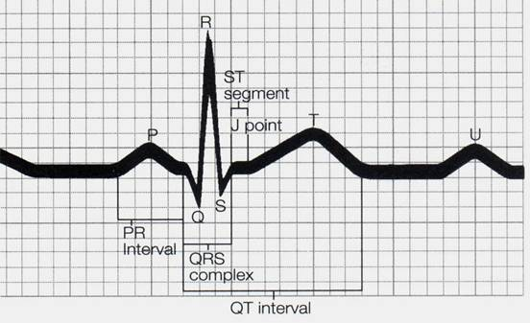

Rate 60-100 bpm

Rate 20-40 bpm

Rate 40-60 bpm
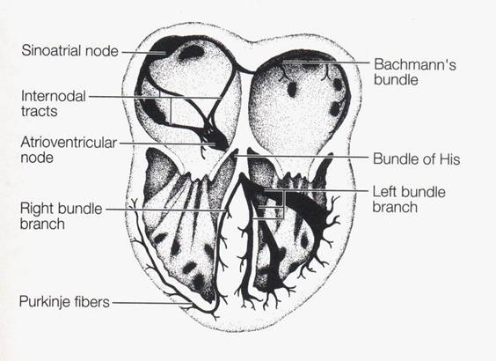

A
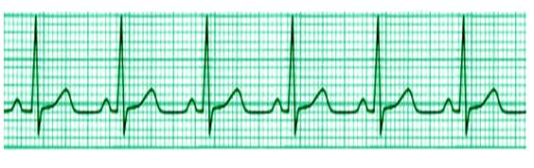

B

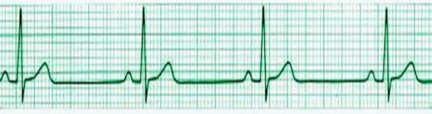

C

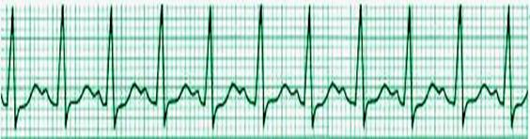

D

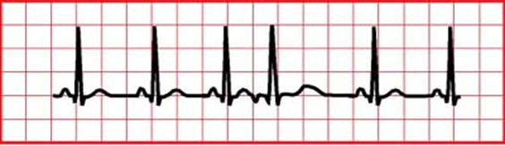

E

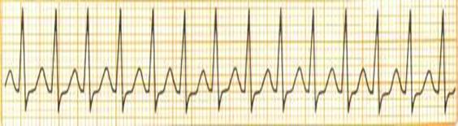

F

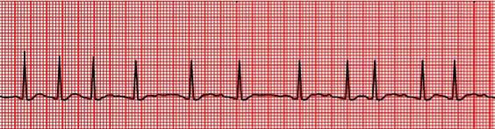

G

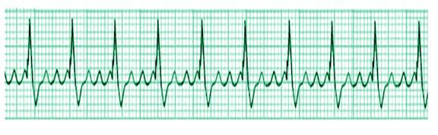

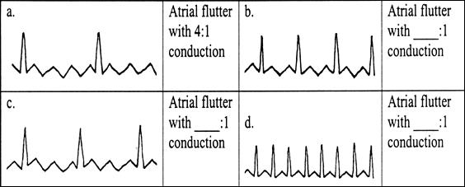

H

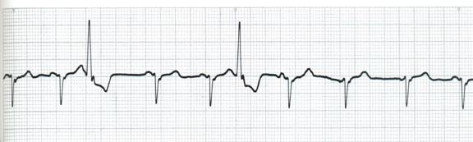

I

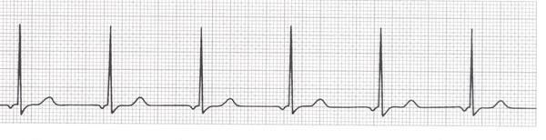

J

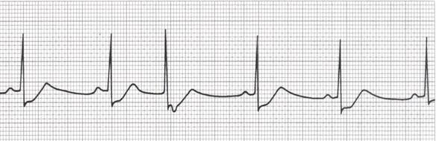

K

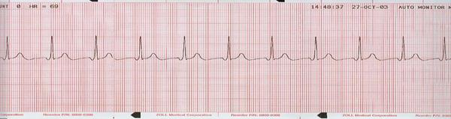

L

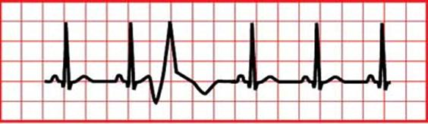

M

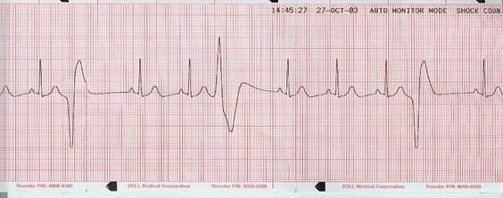

N

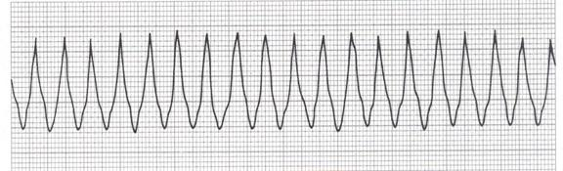

O
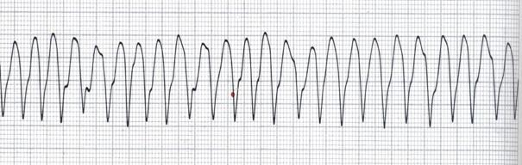

P

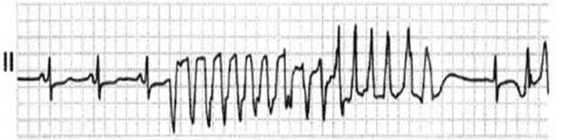

Q
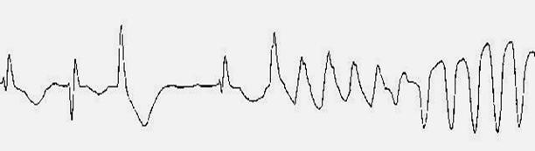

R

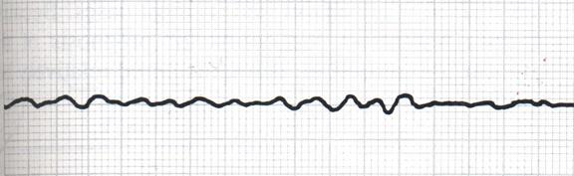

S

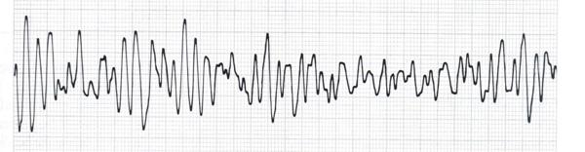

T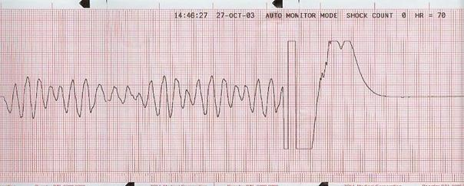

U

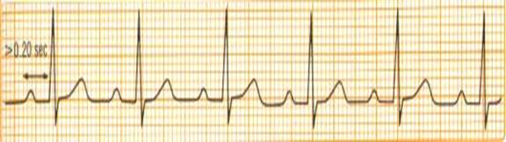

V

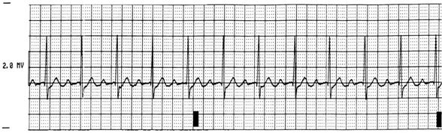

W

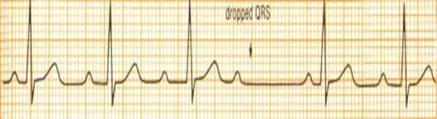

X

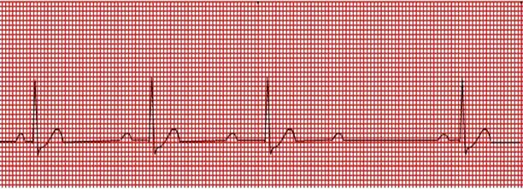
Y
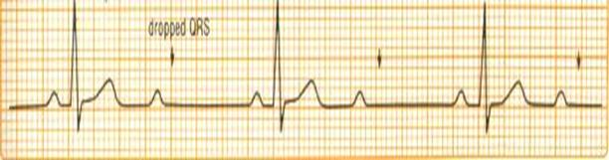

Z
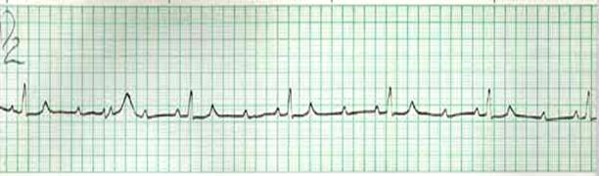

AA

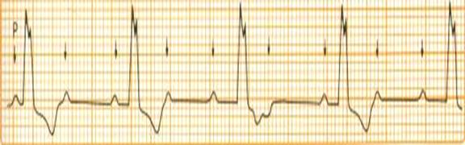

BB

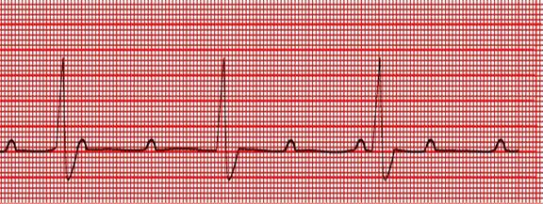

CC

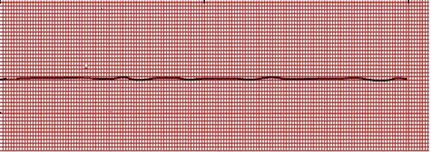

DD
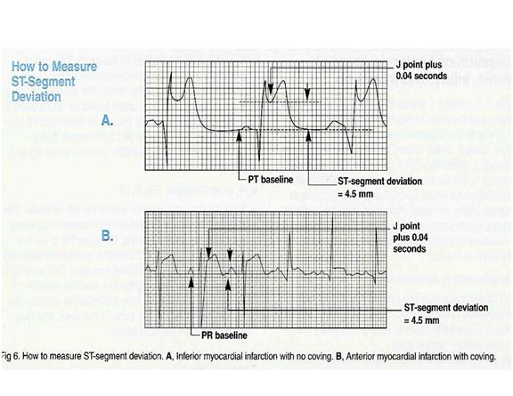

EE

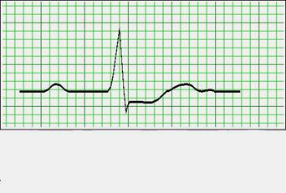

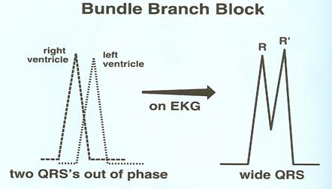

In BBB, one ventricle contracts slightly later than the other, causing two “joined QRS’s to appear on the EKG

The diagnosis of BBB is based primarily on the width and appearance of the QRS. Ask these three questions.

1. Is the QRS wide (> 0.12 seconds)
2. Look for R and R’(prime) (only in V1 and V2 or V5 and V6)
3. Look on the right (V1 or V2) or left side (V5 and V6) of the heart.
This is generally accurate for the basic right and left bundle branch blocks.

Are these right or left BBB?

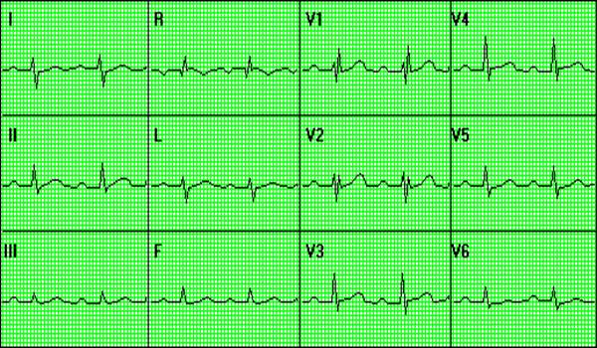

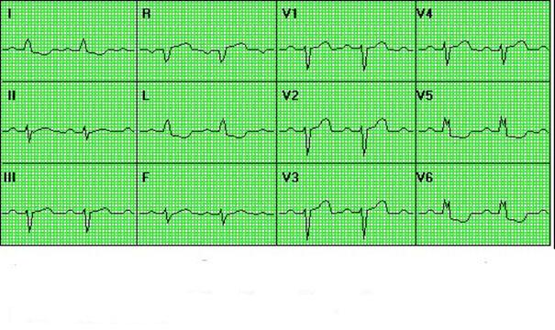

EKG Study Packet Answer Key
- Sinus Rhythm
- Sinus Brady
- Sinus Tach
- Sinus Rhythm w/ PAC (look for the inverted P wave. Upright P waves generally are above the baseline.
- SVT ( No P waves, narrow complex )
- Atrial Fibrillation ( No regular Ps, variable rate and fibrillatory baseline)
- Atrial Flutter
- Wandering Atrial Pacemaker (WAP)/If > 100 = Multifocal Atrial Tach (MAT)
- Junctional Rhythm.~ 60 bpm
- Sinus Rhythm W/ ST Depression and a PJC
- Junctional Tach @ 110 bpm
- Sinus Rhythm W/ PVC
- Sinus Rhythm W/ multifocal PVC’s
- Monomorphic V-Tach
- Polymorphic V-Tach (Probably normal QT)
- Polymorphic V-Tach / Torsades de Points ( Prolonged QT)
- Polymorphic V-Tach / Torsades de Points
- Fine V-Fib
- Coarse V-Fib
- Coarse V-Fib that goes into asystole after a defibrillation
- 1st Degree
- 1st Degree
- 2nd Degree type I
- 2nd Degree type I
- 2nd Degree type II
- 2nd Degree type II
- 3rd Degree
- 3rd Degree
- Asystole
- STEMI
- Non STEMI
Bundle Branch Block, right and then left

